# GRAZIOSO SALVARE – AUSTIN ANIMAL SHELTER PROJECT

## About the Project/Project Title

*Grazioso Salvare identifies dogs that are good candidates for searching and rescue training. The dogs are specifically trained to be able to find and help rescue humans or other animals, who are in life-threatening situations. Grazioso Salvare has noted that there are specific types of breeds of dogs that can be trained. The dogs which are going to be trained must meet some specific characteristics such as age. Grazioso Salvare is seeking a software application that allows them to identify and categorize available dogs.*

## Motivation

*Grazioso Salavare needs a way to filter the dog’s information to find the best prospects to train. As Grazioso Salvare requested, the dashboard will be user-friendly*

## Getting Started

*The full-stack team will create the Grazioso Salvare platform following these steps.*

1. *Open terminal window*
   1. *Start the mongo server using the command /usr/local/bin/mongod_ctl start no-auth*
   2. *Type the command: mongoimport –port ***** --db AAC –collection animals –headerline /us/local/datasets/aac_shelter_outcomes.csv (NOTE: ***** will be replace by your port number)*
   3. *The command will import the documents. I fail to make sure that you type the command exactly as provided*
2. *Jupiter Notebook*

*\*\*Note for a better organization it’s recommended to create a new folder for the .py and .ipynb\*\**

* 1. Table

     Description automatically generated with medium confidence*Upload the ProjectTwoDashboard.ipynb file and utilize the previous CRUD python file*

## Installation

The platform will require the implementation and functionality of the following:

* *Python*
  + *Python interpreter*
    - * [*https://www.python.org/downloads/*](https://www.python.org/downloads/)
    - *Installation Video*
      * [*https://www.youtube.com/watch?v=VkdkwxGka3M*](https://www.youtube.com/watch?v=VkdkwxGka3M)
  + *PyMongo*
    - * [*https://pypi.org/project/pymongo/*](https://pypi.org/project/pymongo/)
    - *Installation Video*
      * [*https://www.youtube.com/watch?v=NL_pJPBLV9g*](https://www.youtube.com/watch?v=NL_pJPBLV9g)
* *MongoDB:*
  + *Shell*
    - * [*https://www.mongodb.com/try/download/shell*](https://www.mongodb.com/try/download/shell)
    - *Installation Video*
      * [*https://www.youtube.com/watch?v=6_NSkDRXPZk*](https://www.youtube.com/watch?v=6_NSkDRXPZk)
* *Jupyter Notebook*
  + - * [*https://jupyter.org/install*](https://jupyter.org/install)
    - *Installation Video*
      * [*https://www.youtube.com/watch?v=AuTkAWEa06E*](https://www.youtube.com/watch?v=AuTkAWEa06E)
* *Dash*
  + - * *<https://github.com/plotly/jupyter-dash>*

## Usage

*The application has CRUD (Create, Read, Update and Delete) which is available to modify the database and access based on the criteria. After the setup, the full-stack development team will design the dashboard to meet Grazioso Salvare requirements.*

### Code Example

*CRUD.py*

* Graphical user interface, text, application, email, website

  Description automatically generated*Create method that inserts a document into specified MongoDB and collection*
* A picture containing text

  Description automatically generated*Read Method that queries for documents(s) from specified Mongo DB database and specified collection*
* A picture containing graphical user interface

  Description automatically generatedUpdate method that queries for and changes document(s) from specified Mongo DB database and specified collection
* Delete that queries for and remove document(s) from a specified Mongo DB database and specified collection

*ProjectTwoDashboard.ipynb*

* *Imports*

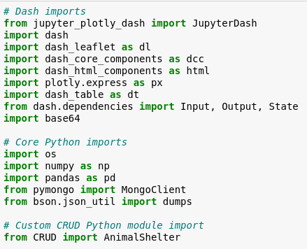

* *User and Password*

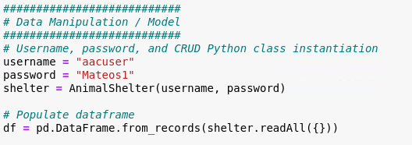

* *Authentication*

* *Map and Chart*

* *Update Dashboard*

* *Update Style*

* *Update Graph*

* *Update Map*

### Tests

*Grazioso Salvare database was successfully run and the result was the following*

* *Dashboard which contains the authenticator, data table,widgets, geographic location, and pie chart. The dashboard shows the breakdown of the different categories that Grazioso Salvare is available to select from.*

* *Water Rescue and Age: The following dashboard display when the widget is been changed to “Water Rescue” and the category was updated to “Age” is modified. By this, Grazioso Salvare can identify the best candidates who qualify for the job needs and is filtered by age.*

* *Mountain or Wilderness Rescue and Breed: The following dashboard will display when the widget is changed to “Mountain or Wilderness Rescue” and the category was modified to “Breed”. Grazioso Salvare is available to select the best candidates based on their breed.*

* *Disaster or Individual Tracking and Age: The following dashboard will display when the widgets are changed to “Disaster and Individual Tracking” and the category was modified to “Age”. Grazioso Salver is available to select the best candidates based on their capabilities that are required and their age.*

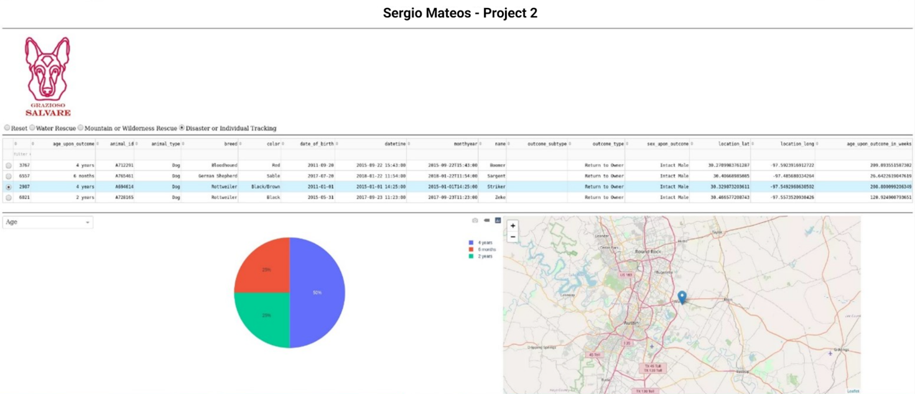

* *Reset: The following dashboard will display based on when the widget is set to “Reset”. The filters will clear out and, on the category, will change to “Outcome Type”.*

* *Pie Chart: The pie chart provides accurate information to Grazioso Salvare about the breed and age. Grazioso Salvare can identify the diversity of the candidates*

* *Geographic location: Grazioso Salvare is available to locate the participants by clicking their names on the list.*

## Roadmap/Features (Optional)

*The dashboard was created without any bugs. Also, to facilitate interaction with the dashboard it was created in a friendly and easy-to-follow version. There is room to improve and if there is any problem present it would be solved as soon as possible.*

*Grazioso Salvare’s dashboard development was challenging since the implementation of the chart and images was something new for the team. Implementation and maintaining every part of the code fully developed and functional was a challenge that was overcome by diving the work into small tasks.*

## Contact

Your name: Sergio Mateos

[sergio.mateos@snhu.edu](mailto:sergio.mateos@snhu.edu)